George Paulson Memorial/Denison University Scholarship Fund

George N. Paulson graduated in 1949 from Denison University. Upon his death, a fund was created with the Community Foundation to honor his memory and provide scholarship funds for Denison University students. There is also a memorial fund in the name of George Paulson and his wife Carolyn that helps fund the Williamsport Public Library.

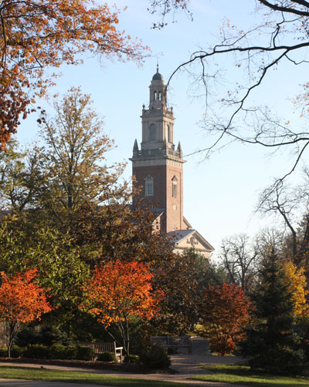
Denison University

