Warren County Education Fund
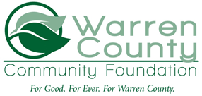
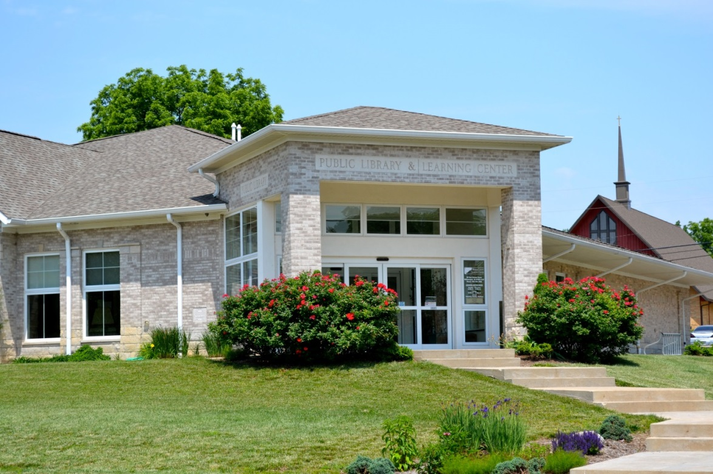
In 2003, the Metropolitan School District of Warren County established an education fund with the Foundation. The purpose of this fund is to promote education and support the educational needs of the school district, as well as sustain programs created under the CAPE initiative. One of the main programs supported by this fund is the Learning Center, which provides a variety of classes, including an adult GED program. Education is planning for the future, and this fund provides the funds necessary to help Warren County get kids and adults on the right track through learning.

