Clark-Thomas Speech Pathology Scholarship
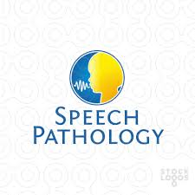
Wini Clark is a lifetime resident of Warren County. She served as a Speech-Language Pathologist for over 40 years in the public school systems of Fountain, Warren and Vermillion Counties. Karen Clark Thomas, is Wini’s daughter, and is also a Speech-Language Pathologist. Karen served in the medical setting, with over 19 years of service with Lutheran Health Network in Fort Wayne, Indiana. Karen is still a practicing SLP in the Indianapolis area, serving pediatric through the geriatric in a private clinic and the healthcare settings.
Wini and Karen know the joys of serving others in the field of Speech-Language Pathology. They wish to encourage students to pursue a Bachelor's and/or Master’s Degree in Speech-Language Pathology or Communication Sciences and Disorders. They hope to help students follow their dreams of serving those with communication disorders in the educational or medical setting through this scholarship.
Students wishing to apply for this scholarship should have a declared major in Speech Pathology. Students can be entering the program as a Freshman. Students that are continuing in their programs as a Sophomore, Junior or Senior may also apply. Returning students must carry a minimum of 3.0 GPA (based on a 4.0 scale). This scholarship is also available to those students accepted into an accredited Master’s program in Speech Pathology. This scholarship will be awarded based on scholarship, activities, and community service.
This is a $1000 scholarship awarded for one academic year. This scholarship is renewable via application and meeting the GPA requirements. Being a recipient one year does not guarantee future years. Applications will be accepted annually and reviewed. The application deadline is January 4th, 2017. Scholars are announced at the awards night in May for graduating seniors. If a college student is awarded the scholarship, this can be announced any time after the selection has been made.
Students wishing to apply for this scholarship should fill out the online application found through this link: https://warrencountyfoundation.awardspring.com/

