Gilbert Bailiff Memorial Scholarship
In December of 2012, his three daughters, Dianna Dushane, Kathy Kuhn, and Carolyn Waters created the Gilbert Bailiff Scholarship Fund in memory of their dad- Gilbert. Gilbert Bailiff was born in 1928 in Marshfield and attended Covington High School. He worked at Brown Rubber Factory for eight years, farmed part-time, and attended journeyman school for printing. He then found employment as a printer with Lafayette Journal and Courier newspaper, and finally retired after 38 years of service. Gilbert believed in hard work and that kind of spirit is what his daughters want to live on through this memorial.
The purpose of this scholarship is to award funding for a student attending a trade school with the following qualifications: a resident of Warren County, a Seeger High School graduate, and a minimum GPA of 2.0.
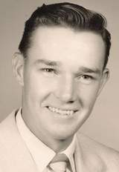
Gilbert Bailiff

